NAME: NARESH ASHOK MALI PRACTICAL 3 ROLL NO:TCOD06
AIM: SQL Queries – all types of Join, Sub-Query and View:

Write at least10 SQL queries for suitable database application using SQL DML statements. Note: Instructor will design the queries which demonstrate the use of concepts like all types of Join, Sub-Query and View
Activity to be Submitted by Students:
Design SQL queries for suitable database application using SQL DML statements: all types of Join, SubQuery and View.
DATABASE:
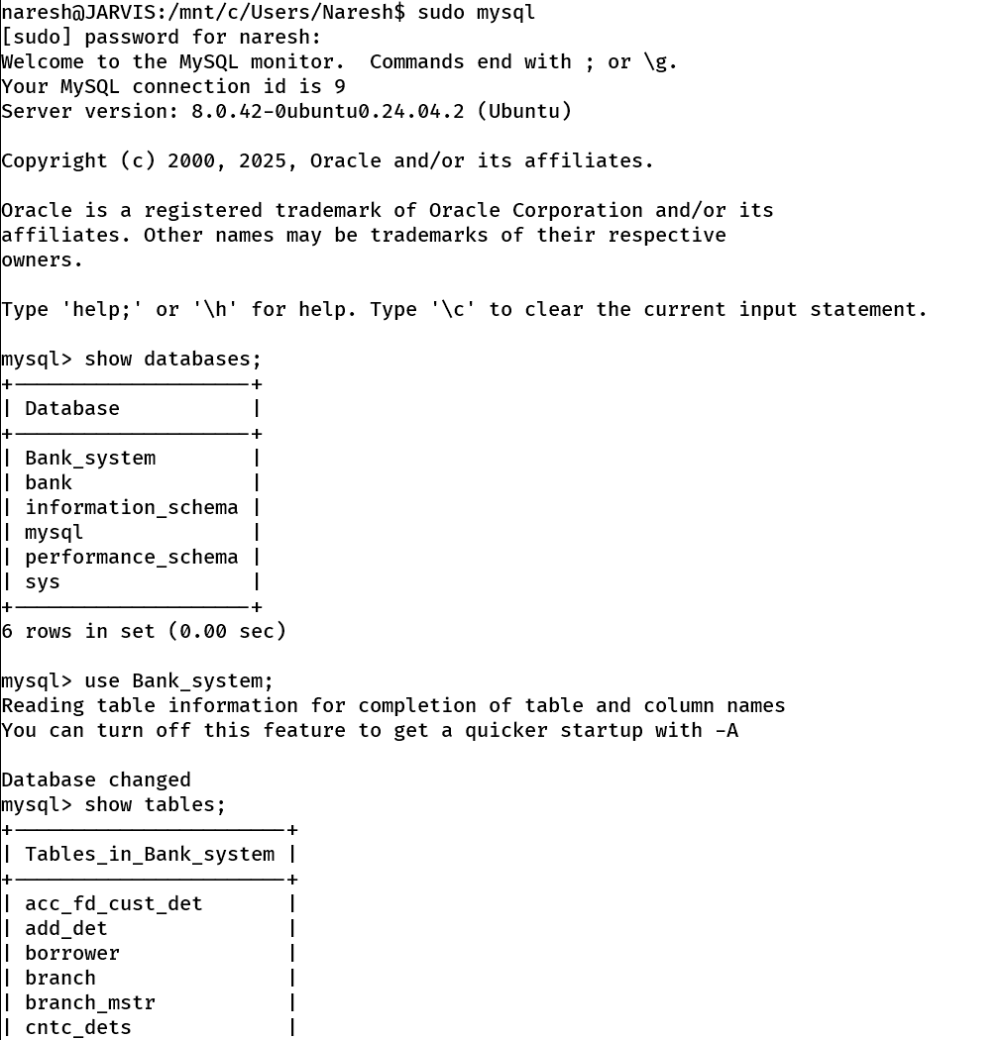
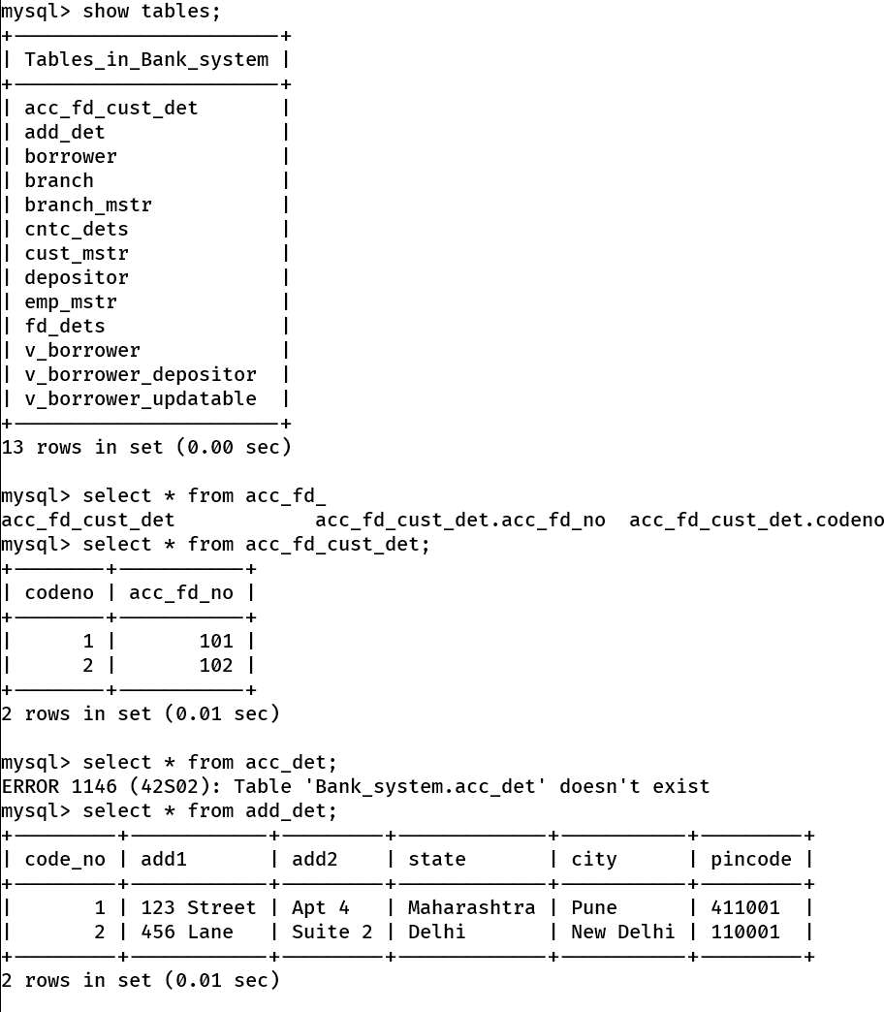
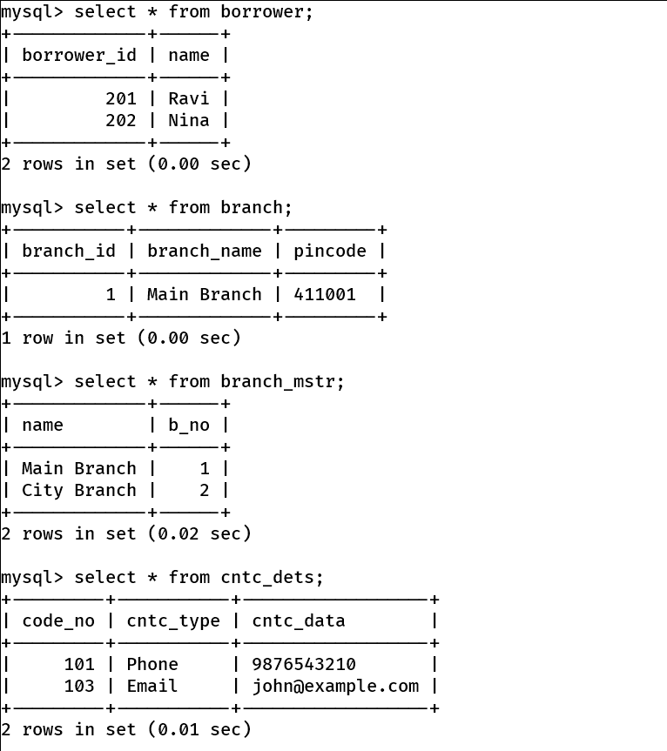
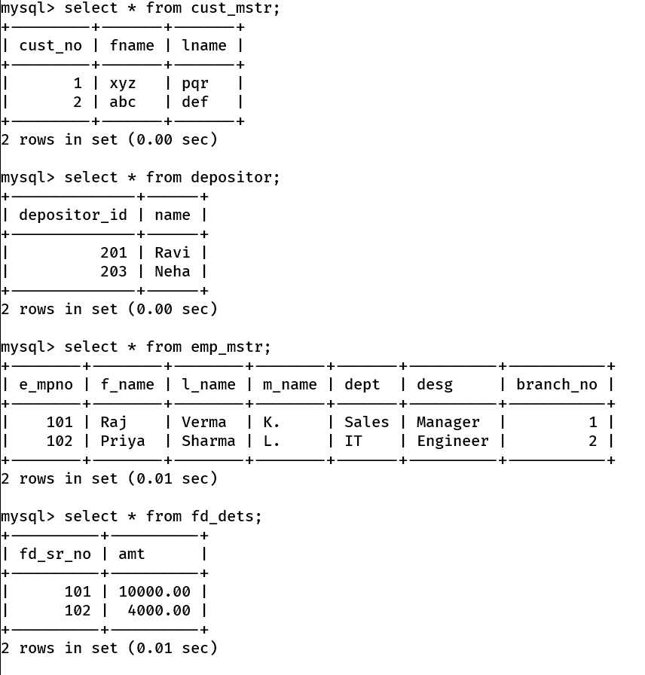
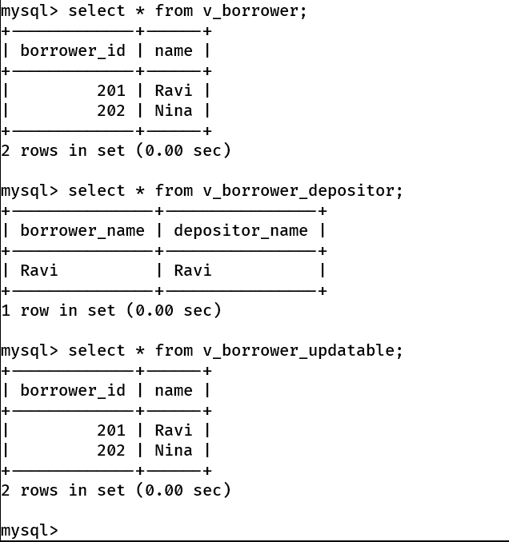
1.Create following Tables
cust_mstr(cust_no,fname,lname)
add_dets(code_no,add1,add2,state,city,pincode)
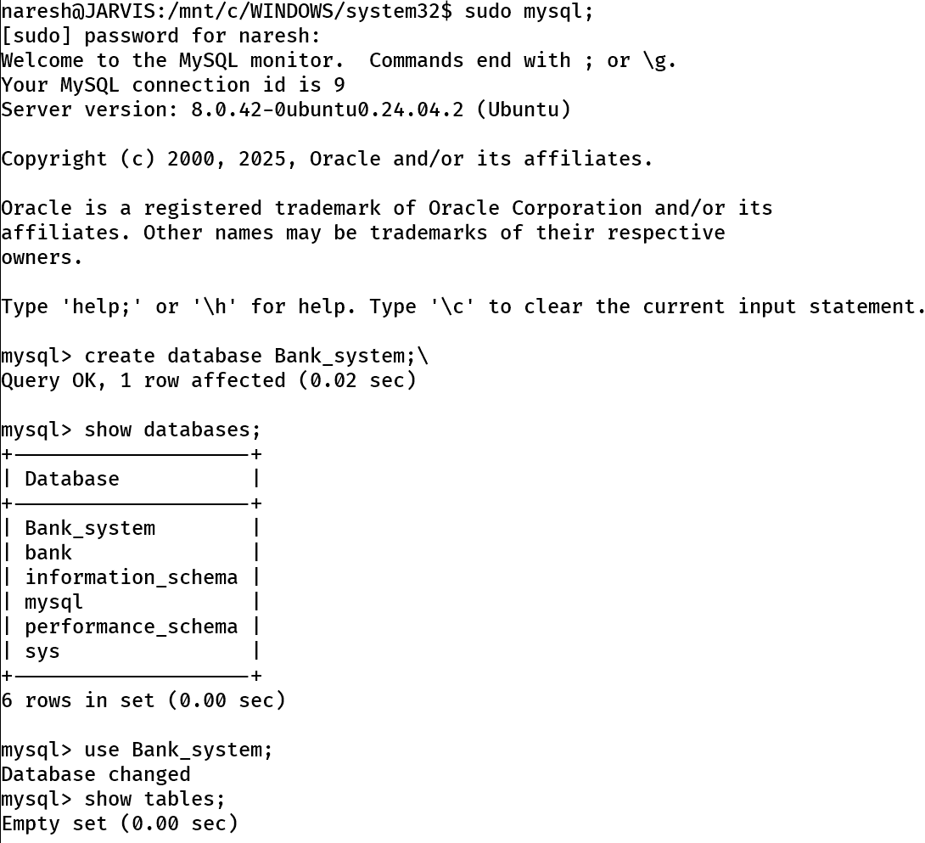
Retrieve the address of customer Fname as 'xyz' and Lname as 'pqr'.
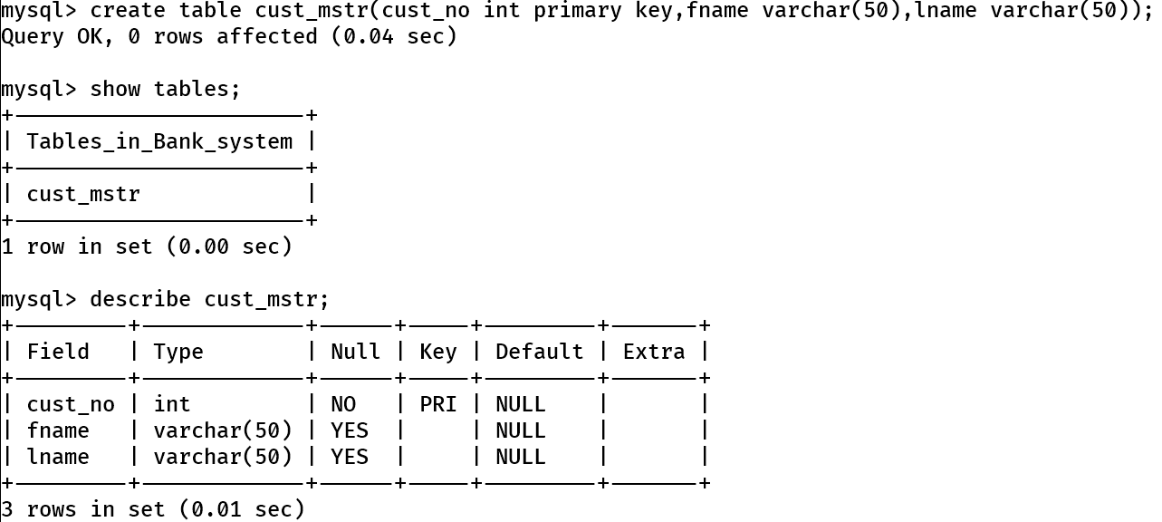
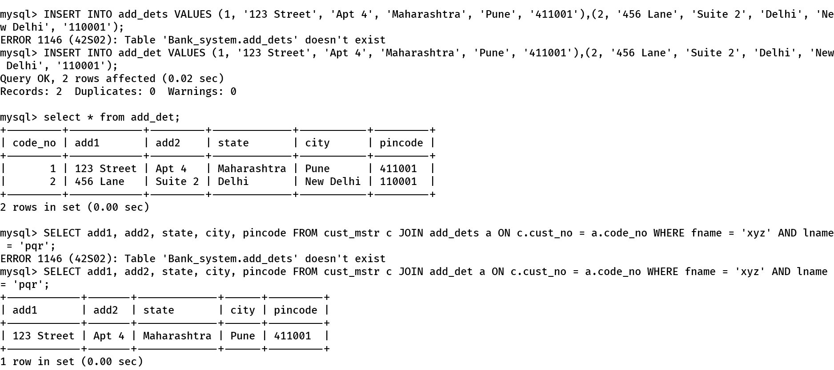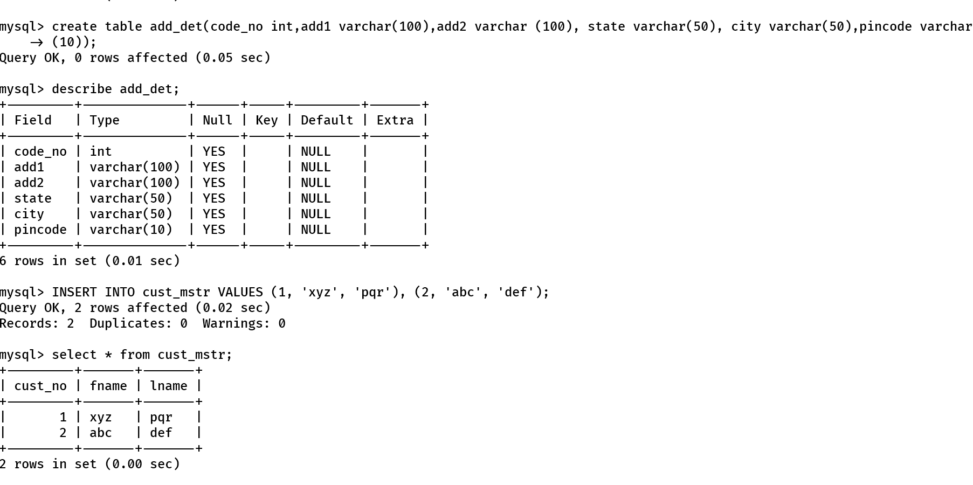

2.Create following Tables
cust_mstr(custno,fname,lname)
acc_fd_cust_dets(codeno,acc_fd_no)
fd_dets(fd_sr_no,amt)
List the customer holding fixed deposit of amount more than 5000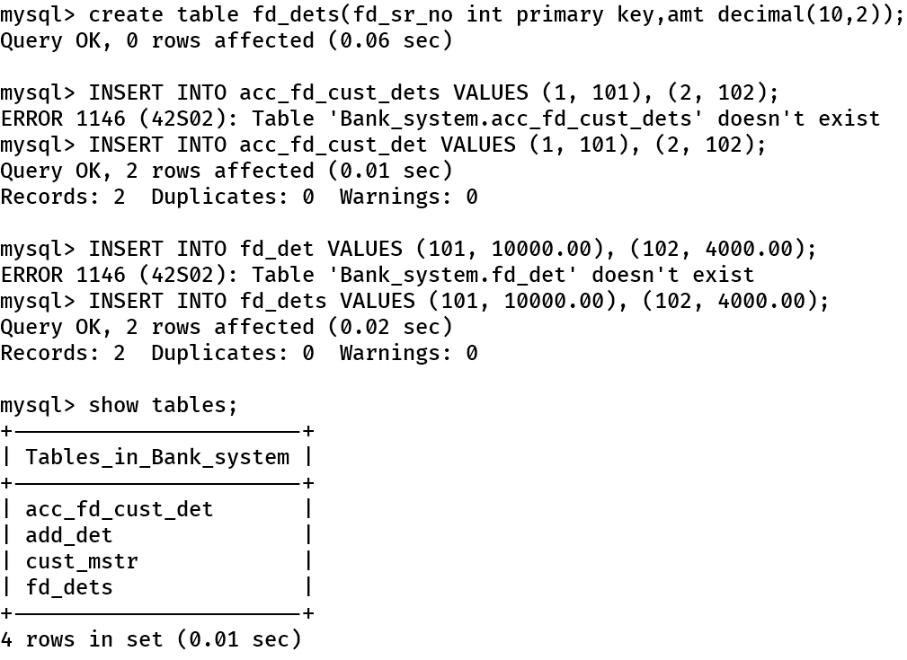
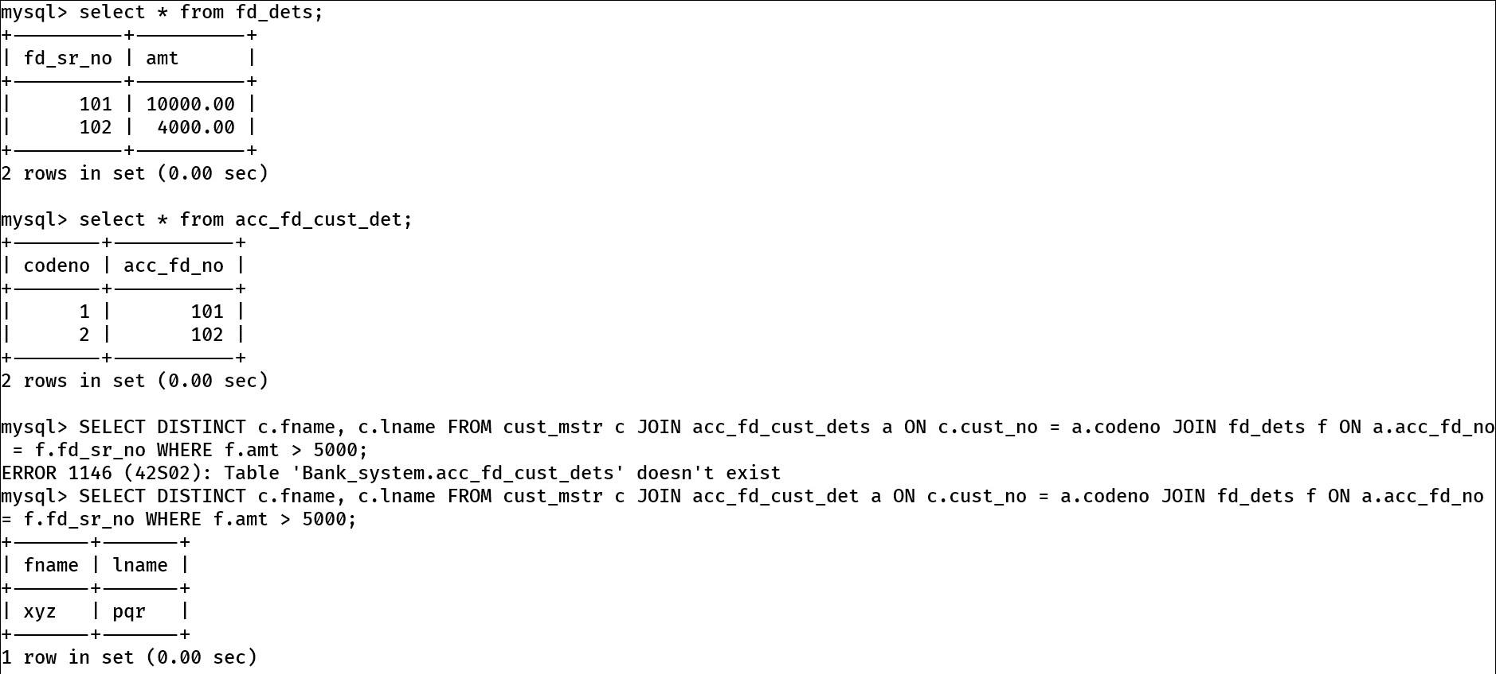

3.Create following Tables emp_mstr(e_mpno,f_name,l_name,m_name,dept,desg,branch_no) branch_mstr(name,b_no)
List the employee details along with branch names to which they belong
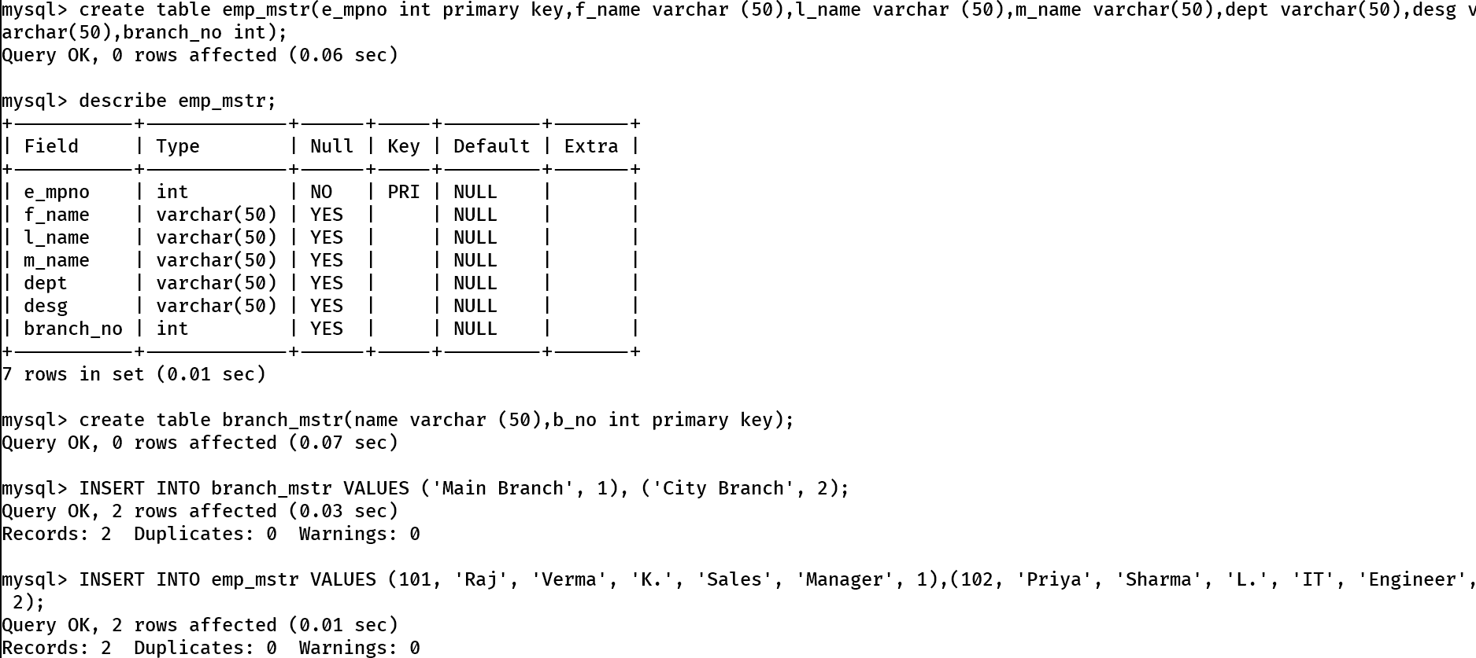
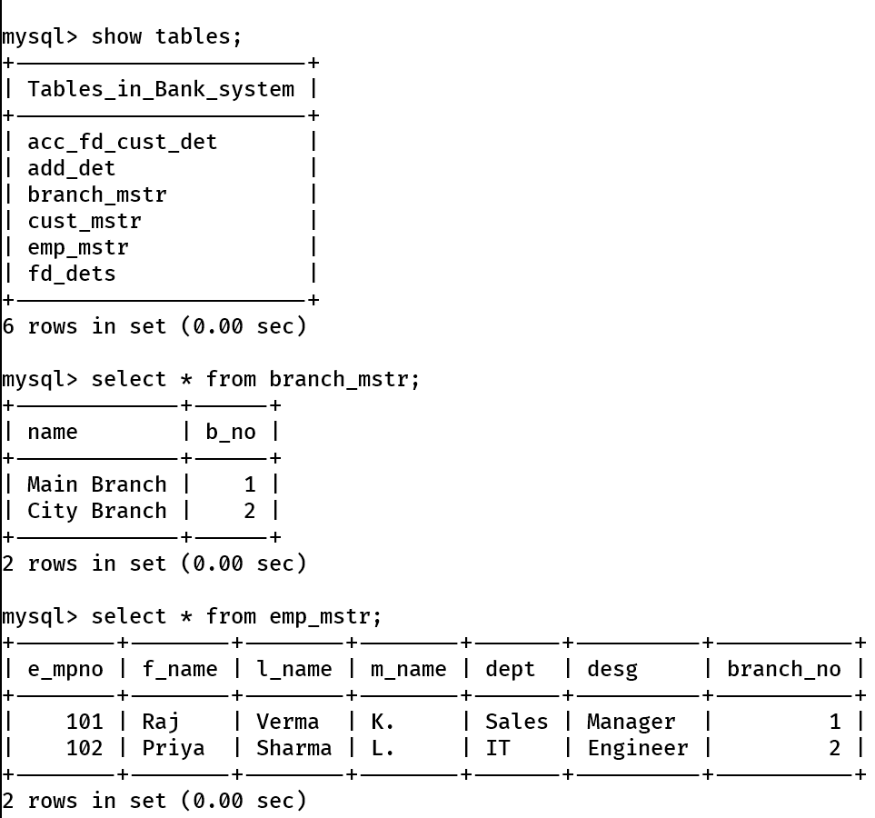
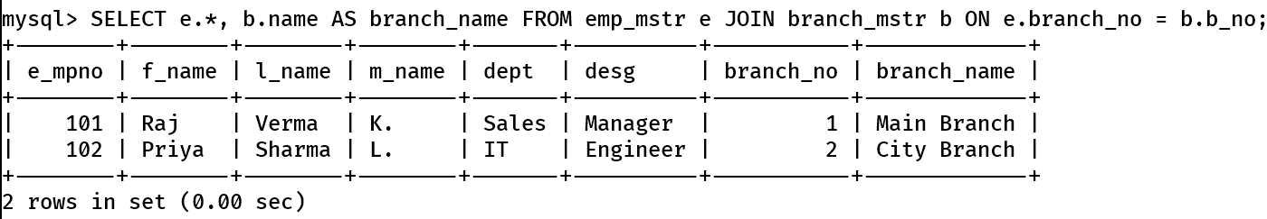

4.Create following Tables
emp_mstr(emp_no,f_name,l_name,m_name,dept) cntc_dets(code_no,cntc_type,cntc_data)
List the employee details along with contact details using left outer join & right join
For left one:
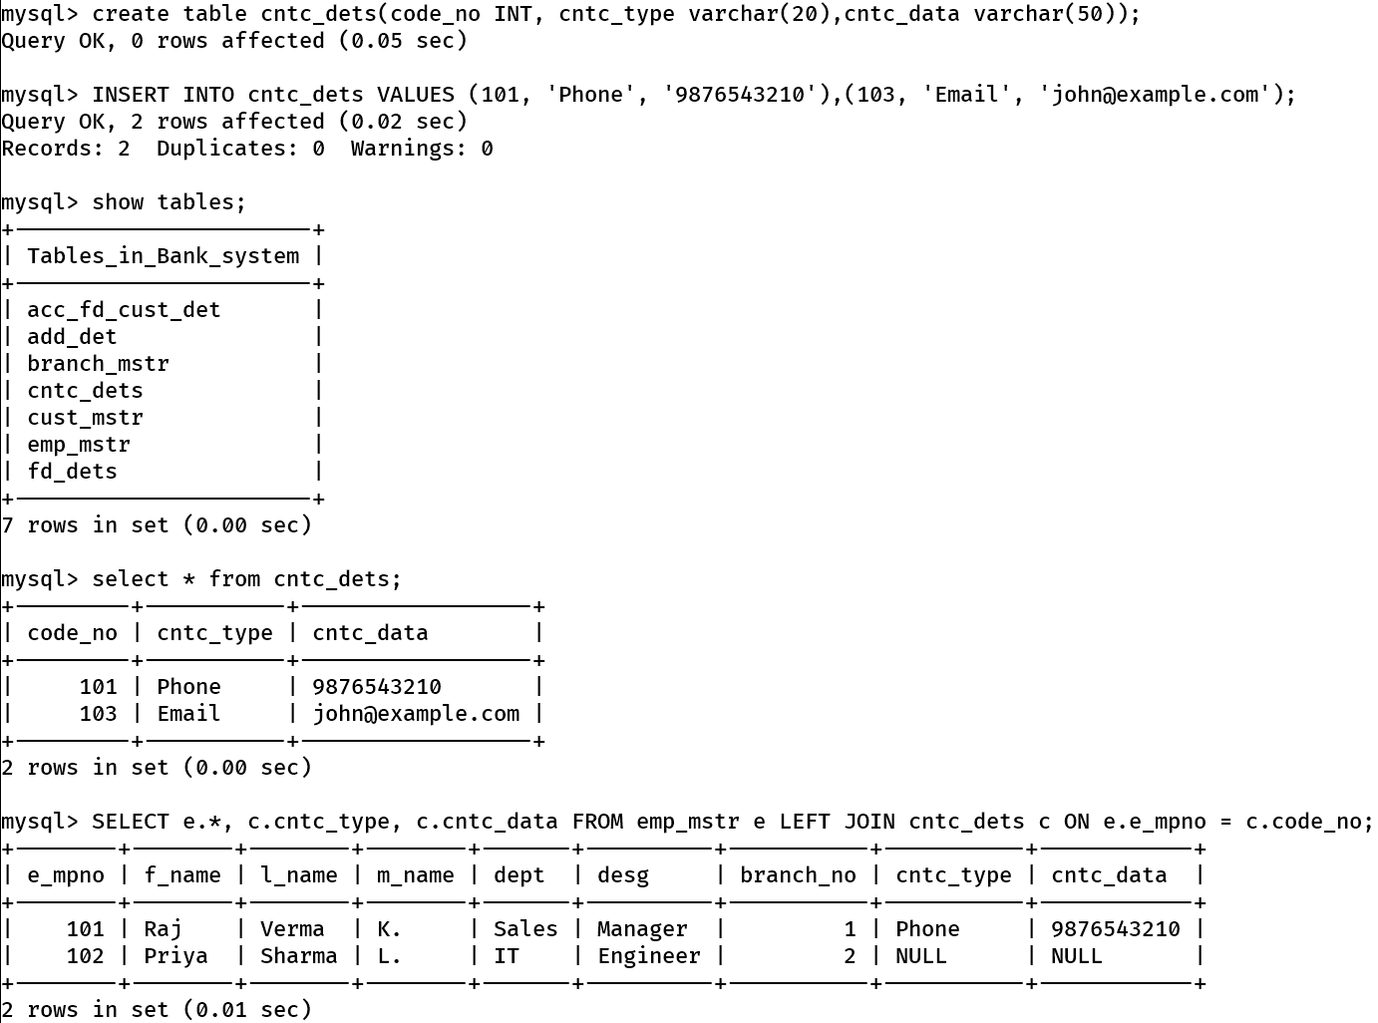
For right one:
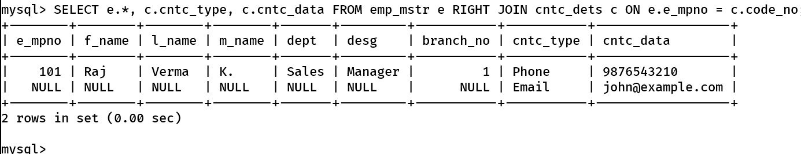

5. Create following Tables
cust_mstr(cust_no,fname,lname)
add_dets(code_no,pincode)
List the customer who do not have bank branches in their vicinity.
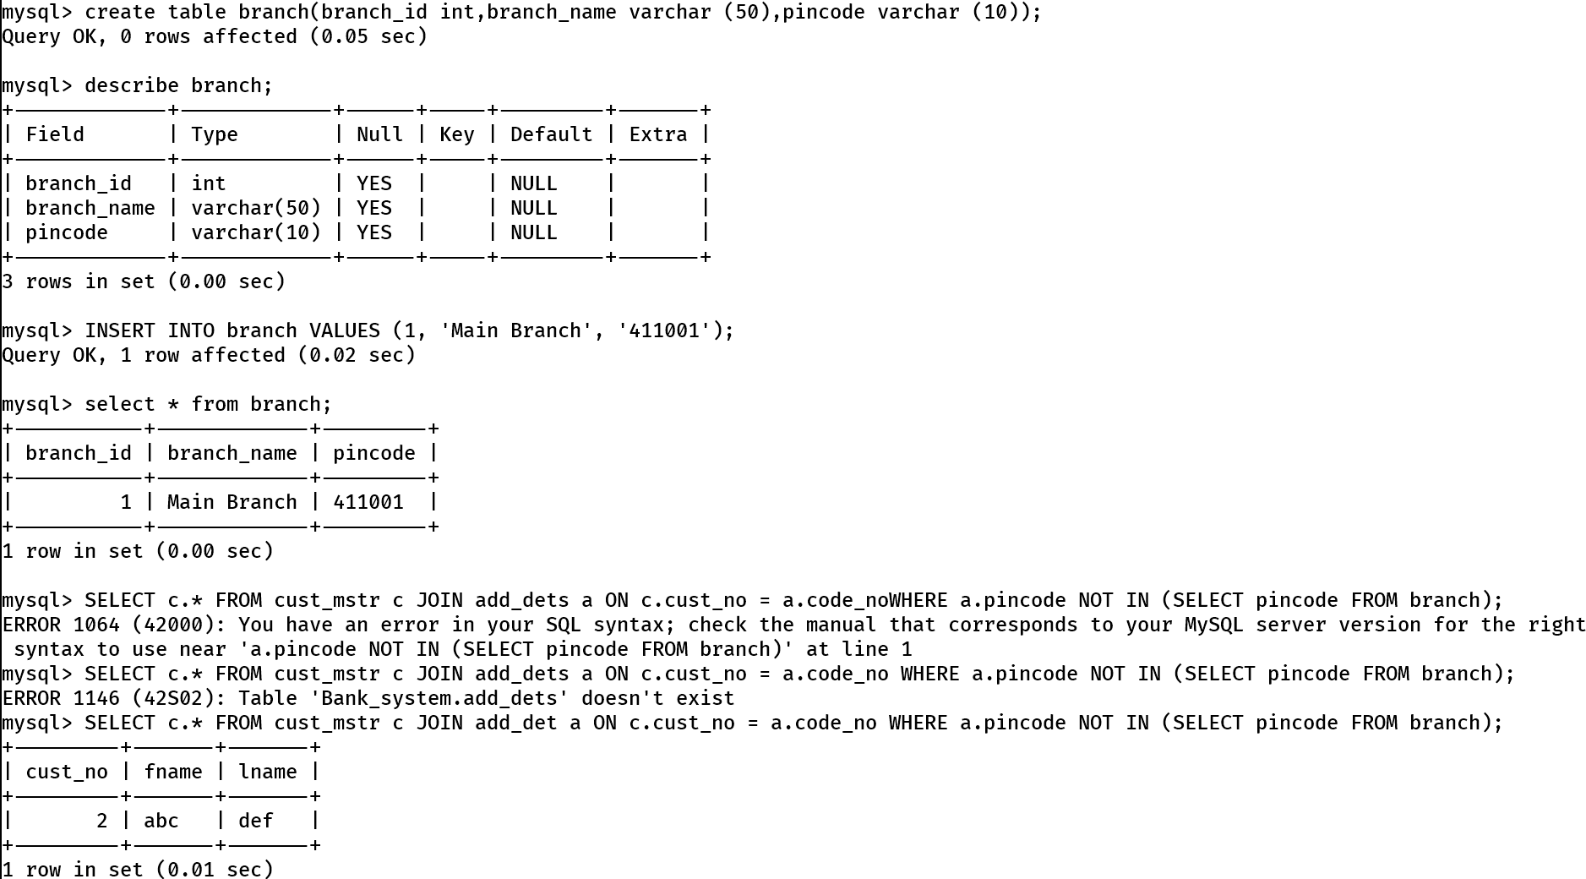

6. a) Create View on borrower table by selecting any two columns and perform insert update delete operations
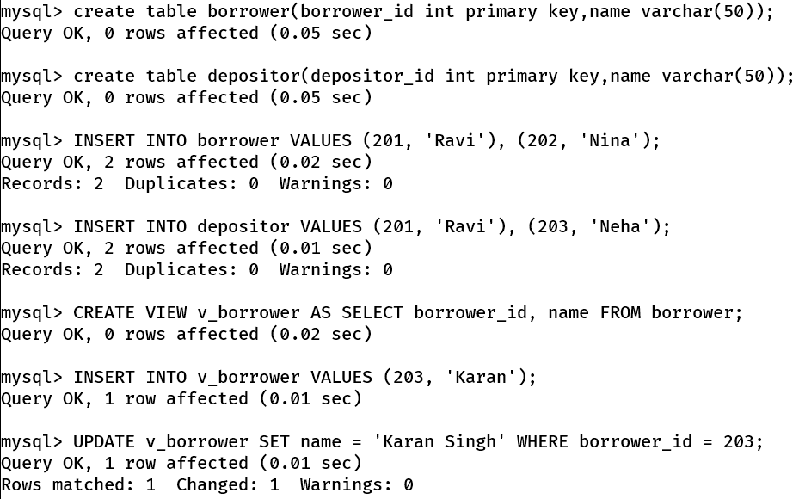
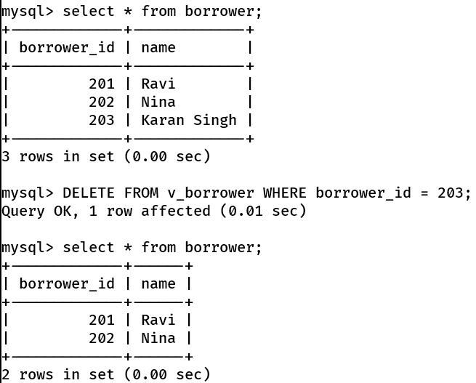
6.b) Create view on borrower and depositor table by selecting any one column from each table perform insert update delete operations
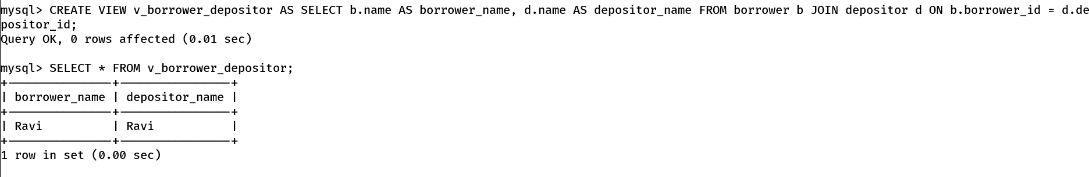
6. c) create updateable view on borrower table by selecting any two columns and perform insert, update and delete operations. 